**Appendix A – Service Structure and Resourcing**

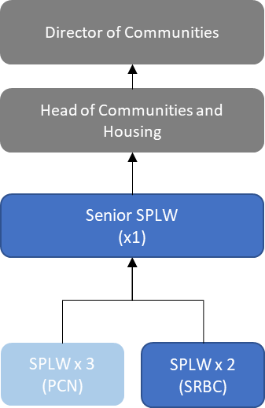

PCN roles are subject to subcontracting and are not funded by South Ribble Borough Council

**Service Costs**

The following costs are based on a range from bottom of scale to top of scale. Senior Social Prescribing Role is subject to Job Evaluation.

Total costs include all pay award, car allowance and on costs.

Oher costs within the summary columns relate to training and travel allowances.

